lication Design

Assignment On DHT11–Temperature And Humidity Sensor

**Submitted To :**

#### **Name** : Propa Punam

#### **Designation :** Lecturer of CSE, UITS

#### **Date of Submission :** 18/12/2024

#### **Cours code** : CSE 402

**Course title :** Internet of Things Lab

ion :Date of Submission :

**Submitted By :**

**Name :** Md Shariful islam sajib sarker

**ID:** 2125051016

**Section:** 7A

**Batch** : 50

# 

# Introduction to DHT11 Sensor

The DHT11 is a low-cost digital sensor designed to measure temperature and humidity. It is widely used in IoT applications due to its simplicity, reliability, and ease of interfacing with microcontrollers. The sensor consists of a capacitive humidity sensor and a thermistor for temperature measurement, both connected to a microcontroller that processes the data and outputs it in a digital format. The DHT11 sensor is particularly useful for indoor climate monitoring, smart agriculture, and weather observation systems.

# Working Principle

The DHT11 sensor operates based on two primary components:

1. **Capacitive Humidity Sensor**: Measures relative humidity by detecting changes in capacitance as moisture levels in the air vary.
2. **Thermistor**: A temperature-sensitive resistor that measures the ambient temperature by detecting resistance changes due to temperature variations.

The sensor transmits the measured data to the microcontroller in a 40-bit digital signal format: 16 bits for humidity, 16 bits for temperature, and 8 bits for error checking. This ensures accuracy and reliability in the transmitted data.

# Specifications

* **Humidity Range**: 20% – 90% RH with ±5% accuracy
* **Temperature Range**: 0°C – 50°C with ±2°C accuracy
* **Operating Voltage**: 3.3V to 5.5V
* **Sampling Period**: 1 second
* **Communication Protocol**: Single-wire digital data output

Compared to DHT22, the DHT11 has a narrower measurement range and lower accuracy but is more affordable, making it suitable for basic applications.

# Applications of DHT11

1. **Home Automation**: For controlling HVAC systems based on temperature and humidity levels.
2. **Weather Monitoring**: To collect and analyze environmental data.
3. **Smart Agriculture**: Ensures optimal growing conditions by monitoring soil and air conditions.
4. **Industrial Systems**: For humidity and temperature regulation in storage and manufacturing facilities.

# Circuit Design

**Components Required:**

* DHT11 Temperature and Humidity Sensor
* Arduino Uno Microcontroller
* Breadboard
* Jumper Wires

**Wiring:**

1. **VCC Pin**: Connect to the 5V pin of the Arduino.
2. **Data Pin**: Connect to digital pin 2 of the Arduino.
3. **GND Pin**: Connect to the GND pin of the Arduino.

A clear circuit diagram is attached below to illustrate the connections.

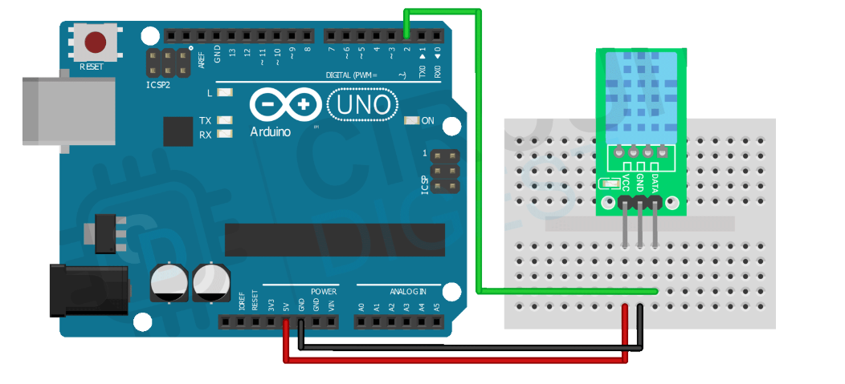

# Programming

Below is the source code to interface the DHT11 sensor with the Arduino:

|  |
| --- |
| #include <DHT.h>  #define DHTPIN 2  #define DHTTYPE DHT11  DHT dht(DHTPIN, DHTTYPE);  void setup() {  Serial.begin(9600);  Serial.println("DHT11 Sensor Initialized");  dht.begin();  }  void loop() {  float humidity = dht.readHumidity();  float temperature = dht.readTemperature();  if (isnan(humidity) || isnan(temperature)) {  Serial.println("Failed to read from DHT sensor!");  return;  }  Serial.print("Humidity: ");  Serial.print(humidity);  Serial.print(" % ");  Serial.print("Temperature: ");  Serial.print(temperature);  Serial.println(" *C");  delay(2000);  } |

# Results and Observations

After running the above code and collecting data, the following results were observed:

|  |  |  |
| --- | --- | --- |
| **Condition** | **Temperature (°C)** | **Humidity (%)** |
| Room Temperature | 25.5 | 55 |
| After Turning on AC | 22.0 | 48 |
| Outdoor Environment | 30.0 | 65 |

The data illustrates how environmental changes affect temperature and humidity levels, confirming the sensor’s functionality.

# Conclusion

The DHT11 sensor is a simple yet powerful tool for measuring temperature and humidity in various applications. Through this experiment, its capabilities and limitations were understood. Future improvements could involve integrating the sensor with IoT platforms for remote monitoring and visualization.

# Reference

* [CircuitDigest. microcontroller-projects/interfacing-dht11-sensor-with-arduino](https://circuitdigest.com/microcontroller-projects/interfacing-dht11-sensor-with-arduino)
* [RandomNerdTutorials. dht22-temperature-humidity-sensor-arduino-ide](https://randomnerdtutorials.com/esp32-dht11-dht22-temperature-humidity-sensor-arduino-ide/)
* OpenAI. (2024). ChatGPT [Large language model]. https://chatgpt.com